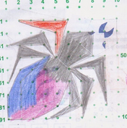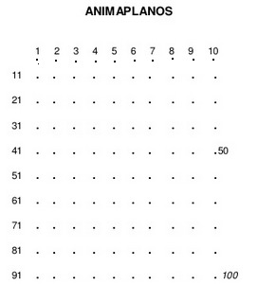

OPERACIONES ACA ABAJO

CICLO:________________________________

ALUMN@:_____________________________

